Spread of binding affinity of 2928 pre-filtered compounds from AfroDB and ANPDB + 5 known inhibitors against aldose reductase (AR) enzyme

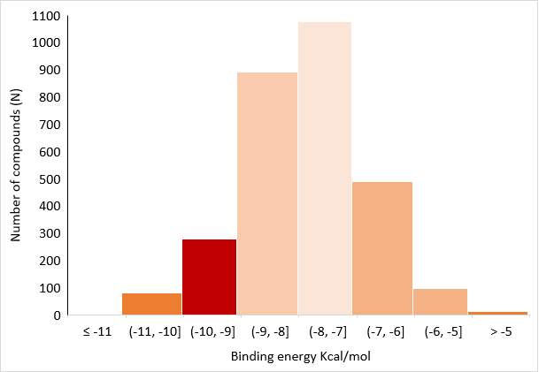

The top 20 compounds with the highest binding affinity to aldose reductase were selected after docking using Autodock Vina

|  |  |
| --- | --- |
| Compound Name | Affinity |
| **Top 20 compounds (AfroDB/ANPDB)** | |
| 4,5-di-p-trans-coumaroylquinic_acid | -12.3 |
| (+)-pipoxide | -11.4 |
| Thymelol | -11.4 |
| Zinc000095485961 | -11.2 |
| Rutamontine | -11.1 |
| (-)-tingtanoxide | -11 |
| Tricoccin_s13_acetate | -11 |
| Lactupicrin | -11 |
| Naamidine_a | -11 |
| Zinc000000134782 | -10.9 |
| Sigmoidin_b_4'-methylether_diacetate | -10.9 |
| (-)-pipoxide | -10.9 |
| Abyssinone_ii | -10.8 |
| (+)-strigol | -10.8 |
| Norisojamicin | -10.8 |
| Calopogonium_isoflavone_b | -10.8 |
| Isosamarcandin | -10.8 |
| (+)-pipoxide-2-methyl_ether | -10.8 |
| Zinc000095485890 | -10.8 |
| 1,6-di-o-p-hydroxybenzoyl-beta-d-glucopyranoside | -10.7 |
| **Standard inhibitors** | |
| Zopolrestat | -9.9 |
| Epalrestat | -8.8 |
| IDD594 | -8.1 |
| Tolerestat | -7.6 |
| Sorbinil | -7.4 |